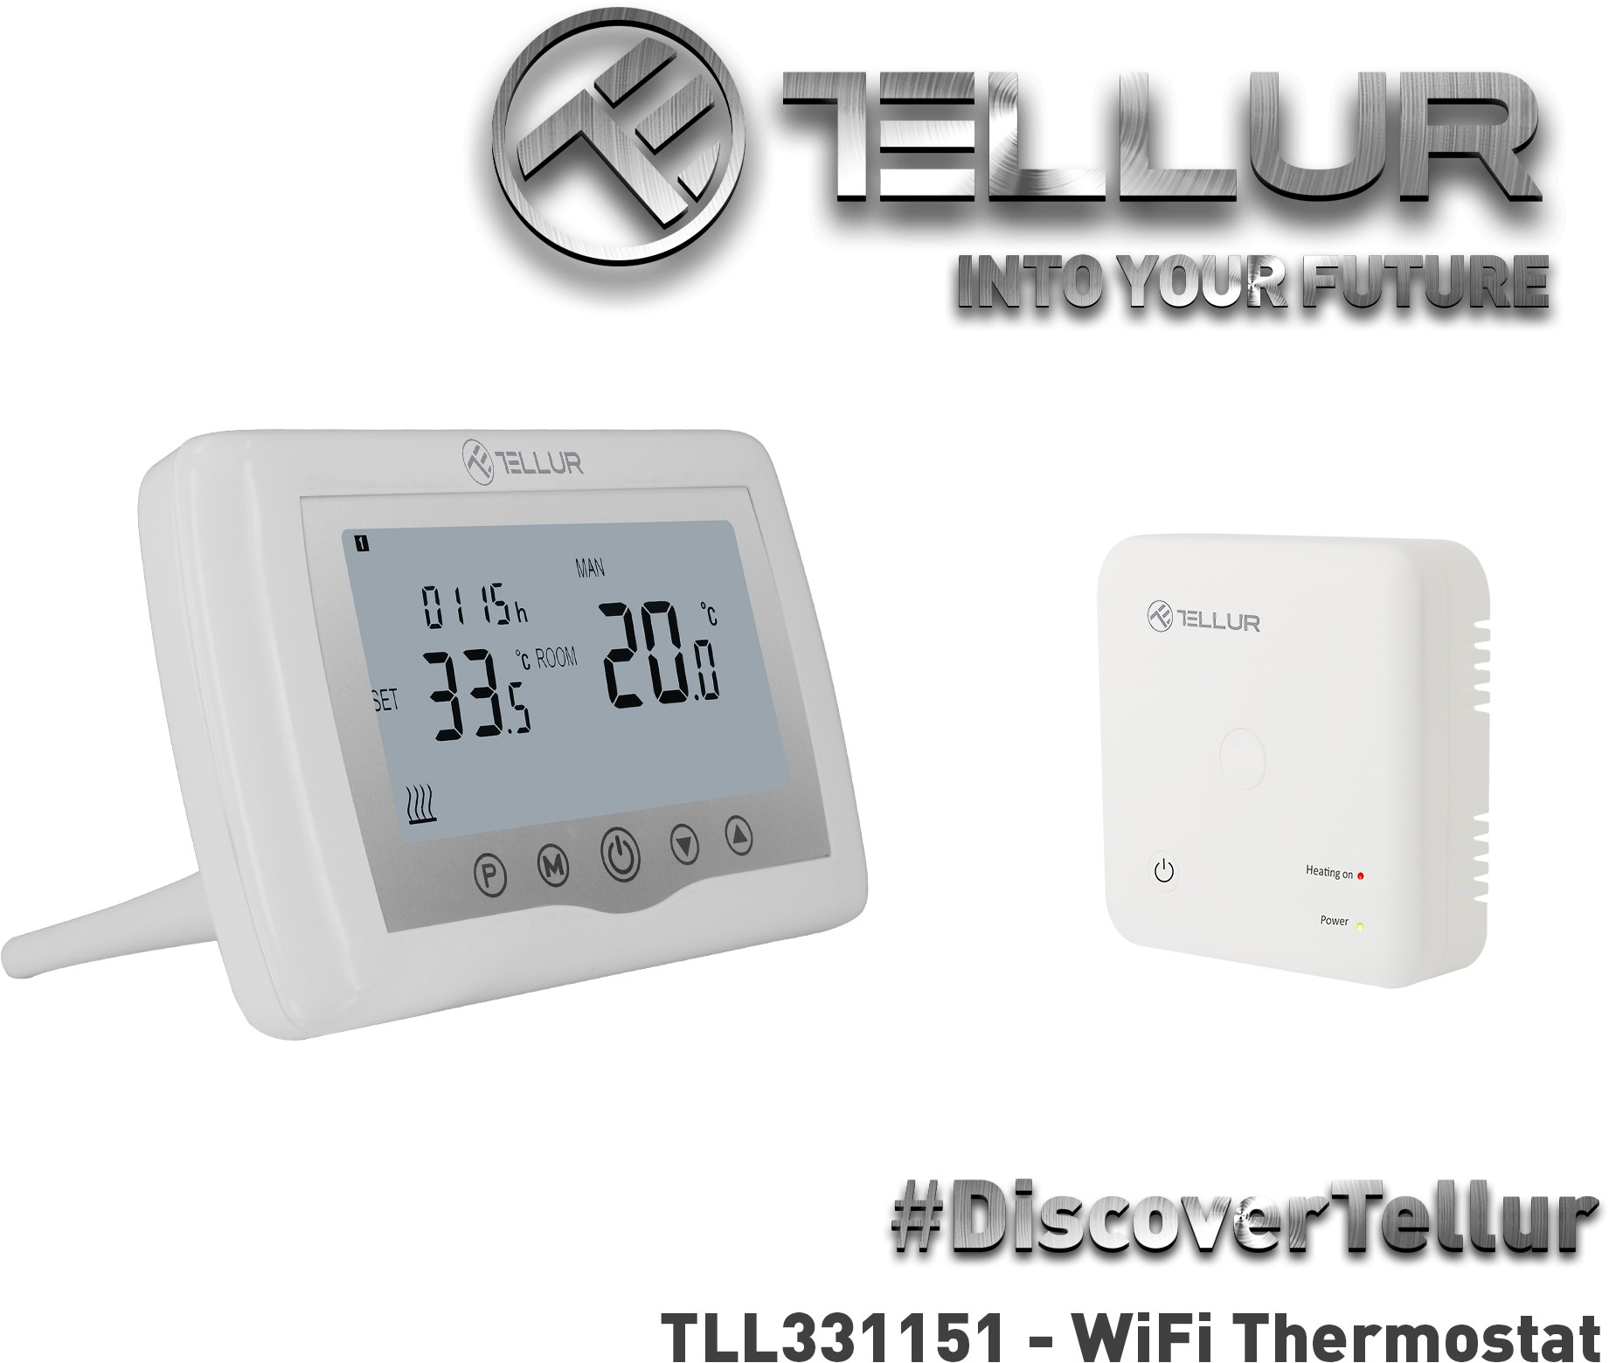

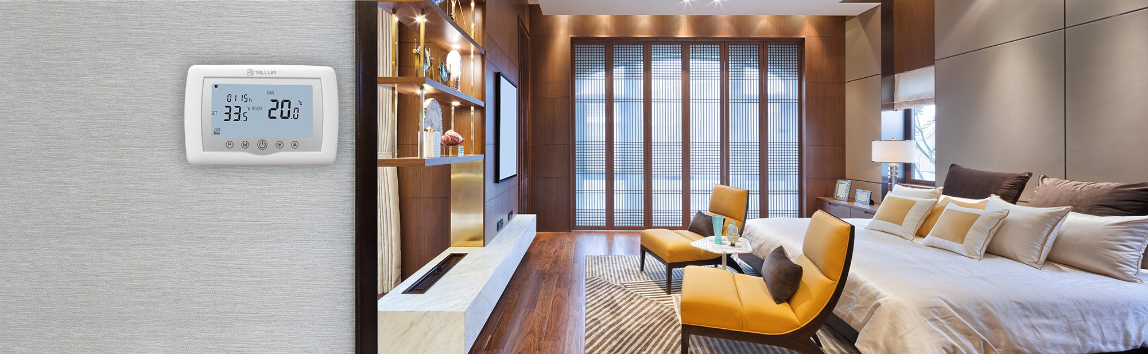

## Enjoy your smart life with Tellur

Create the perfect atmosphere in your home or office with the Wi-Fi Thermostat.

## WiFi Thermostat

Having a 3.7" illuminated LCD display with clear icons, the thermostat is very easy to read and, thanks to the touch buttons, setting the temperature or programme is... well, no sweat whatsoever.

The Tellur Wi-Fi Smart Thermostat supports manual control or fully automatic use via smartphone app. Easily control and adjust the temperature of your home via the Tellur Smart App.

## Characteristics

* Remote control via Tellur Smart app
* Voice control via Google Assistant and Amazon Alexa
* Fully customizable, supports automation and smart scenarios
* Child-lock, schedule, smart functions

# 

### Easy to install and use

With Tellur Smart App, Smart Life App, Tuya App (IOS & Android).

Independent use through internet, only with smartphone.

No hub required. Supports up to 150 registered devices.

Works only with 2.4GHz wireless networks

**Siri Vocal Control**

**Vocal Control**

Control your home’s temperature from anywhere via Tellur Smart app – all you need is your smartphone and an active internet connection.

At home, link your Wi-Fi Thermostat with Amazon’s Alexa or Google Assistant and control it vocally.

### Automation & Smart Scenarios

An automation scenario enables your WiFi Thermostat to execute a command automatically, based on specific conditions such as weather, sunset/sunrise, device state and many others.

For example, you can set your Wi-Fi Thermostat to automatically increase room temperature when the weather outside is snowy.

### Control from anywhere

You can connect to Wi-Fi and control the thermostat by App, warming up to a comfortable pre-set temperature to your house whenever you want, wherever you are!

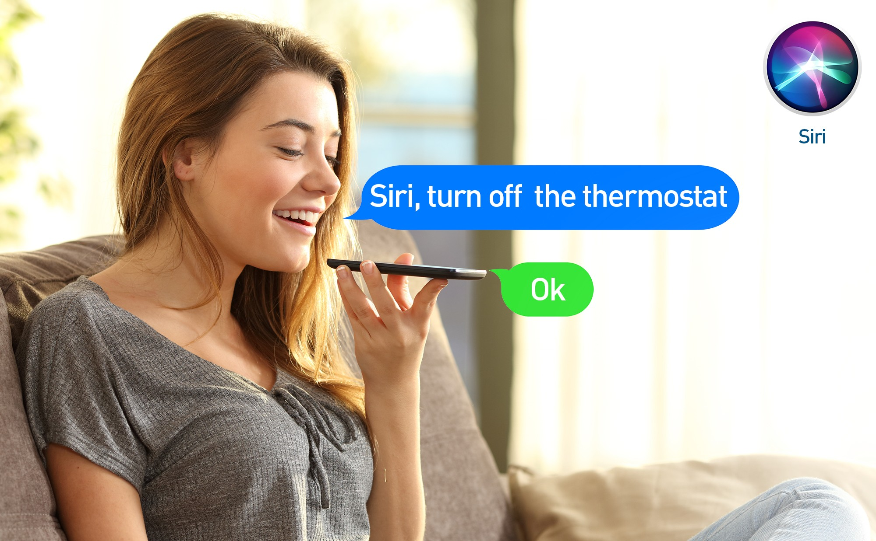

### Works with Siri Shortcuts

Create smart scenario with "Tap-To-Run" function in "Tellur Smart" application

Integrate your new function from "Tellur Smart" app by adding to Siri and rename "When I say" function

Start using your new function giving voice commands to turn on/off the connected device and automatically will execute commands based on your specifications.

# 

### 4 different -7 days program

The 7-days programs function allows you to set 4 different programs for each day of the week, with different timeframes and temperatures for each program

**Dimensions in mm**

### Child lock function

The Child lock function automatically blocks the device’s buttons to secure its settings.

### Frost protection function

The Frost protection function allows the system to maintain the room temperature above a specific value (5° C default value)

### Open Window Detection

The Open Window Detection function allows the system to automatically stop the heating process when it detects a sudden drop of room temperature (2°C in 15 minutes default value).

