# WiFi Smart AC Socket, 2 Ports

**Tellur's WiFi Smart AC socket gives you the power of remote control!**

Easy to install in Tellur Smart APP, the Smart AC socket can be customized and controlled remote via internet from everywhere and you have the possibility to monitor your power consumption.

You have the option to monitor your electricity consumption

Within the application you can see the statistical consumption in KW / h for every day, and the voltage, amperage and watts are displayed in real time for the entire device.

You don't want to overcharge your tablet's batteries? Did you forget to pull your iron off? Don't worry, you have independent control over every socket via your Tellur Smart App.

# Characteristics

* Easy to install and use with TELLUR SMART APP.
* Power consumption monitoring.
* Independent control for each socket.
* Timer, schedule, integrated functions, fully customizable.

# Siri Vocal Control

**Control your new Wi-Fi Smart AC Socket with Siri**

Create smart scenario with "Tap-To-Run" function in "Tellur Smart" application

Integrate your new function from "Tellur Smart" app by adding to Siri and rename "When I say" function

Start using your new function giving voice commands to turn on/off the connected device and automatically will execute commands based on your specifications.

'"·

ooc "'""""'"""""""""' _,,._...,,.._

# Voice control with Amazon Alexa and Google Assistant

Free up your hands by using simply voice commands with Alexa/Google Assistant.

Link your Wi-Fi Smart AC Socket with Amazon's Alexa or Google Assistant and control it vocally. Work automatically after creating on/off schedules or setting auto-off timer routine.

Enjoy a hands-free and responsive connected home by simple voice command:

"Alexa, turn off the Tv".

The configuration guide in Tellur Smart app allows you to set up the plug in 2 minutes.

# Energy control and cost saving

**Automation & Smart Scenarios**

An automation scenario enables your Wi-Fi Smart AC Socket to execute a command

automatically, based on specific conditions such as linked to second device plugged on the same Wi-Fi Smart Socket

For example, you can set up to automatically turn of office desk lamp when the monitor turned Off and passed 3 minutes.

# Control from anywhere

Switch your appliances on/off via smartphone.

Set the smart plug to automatically turn on and off the device according to your needs, even when you are away.

Do you want to have a cool temperature when you get home?Don't worry, because now, you can turn on your air conditioner with your smartphone and the Tellur Smart App.

You can control the devices even when you are at home or not.

The smart plug automatically turns on all household appliances according to your commands or the schedule you set to save energy and save costs. You can use the smartphone application to monitor total energy consumption.

# Schedules and timer settings

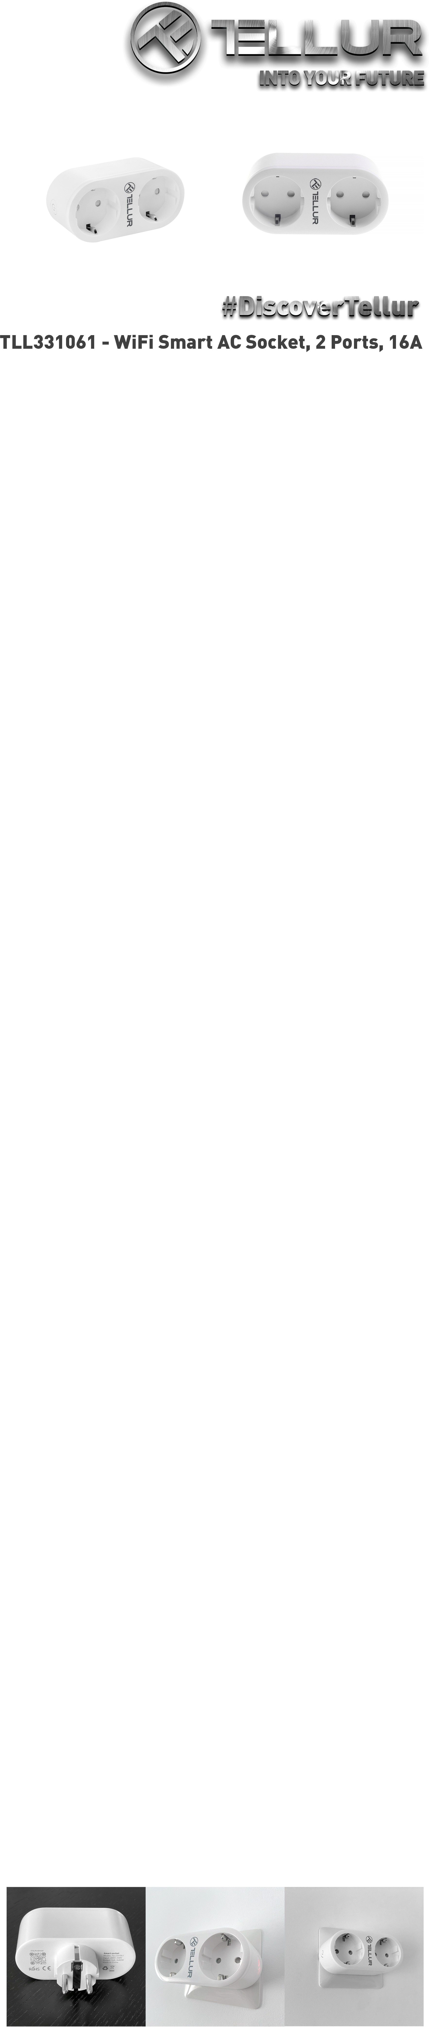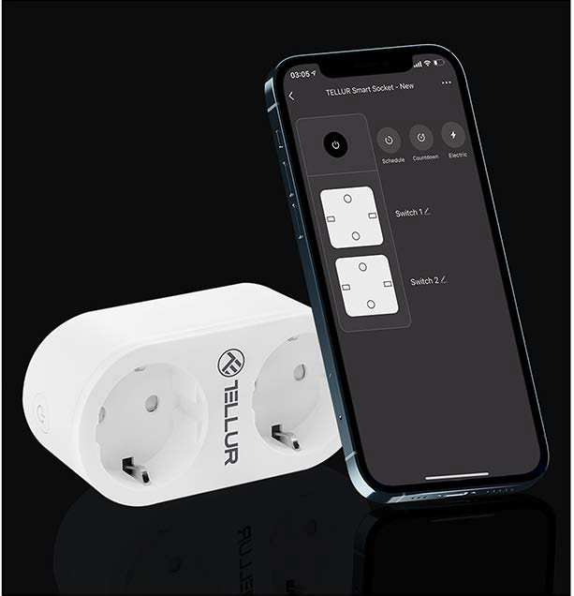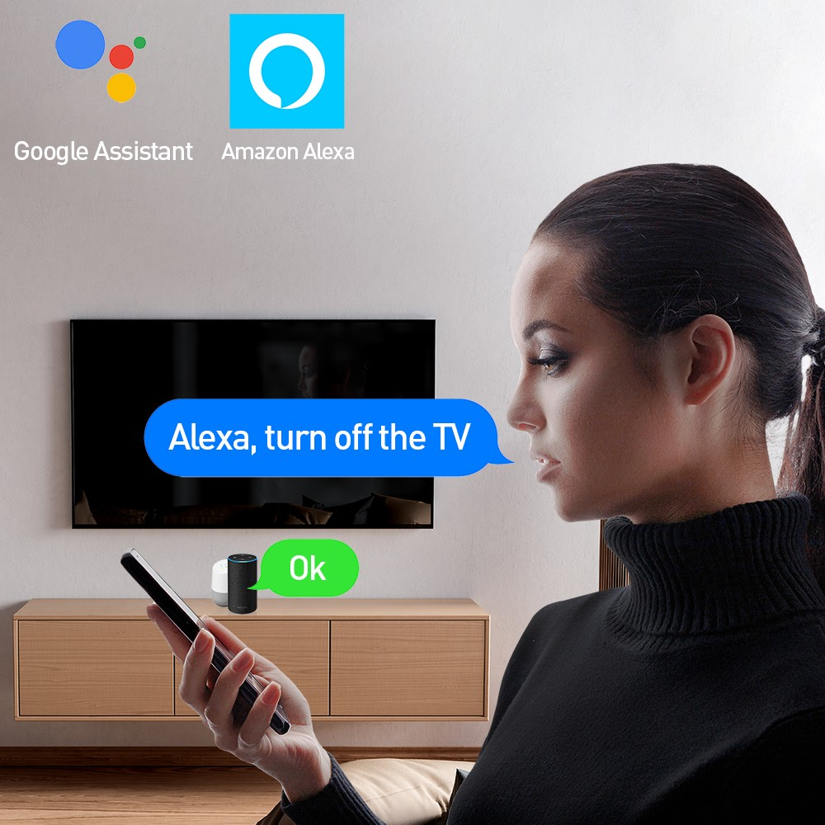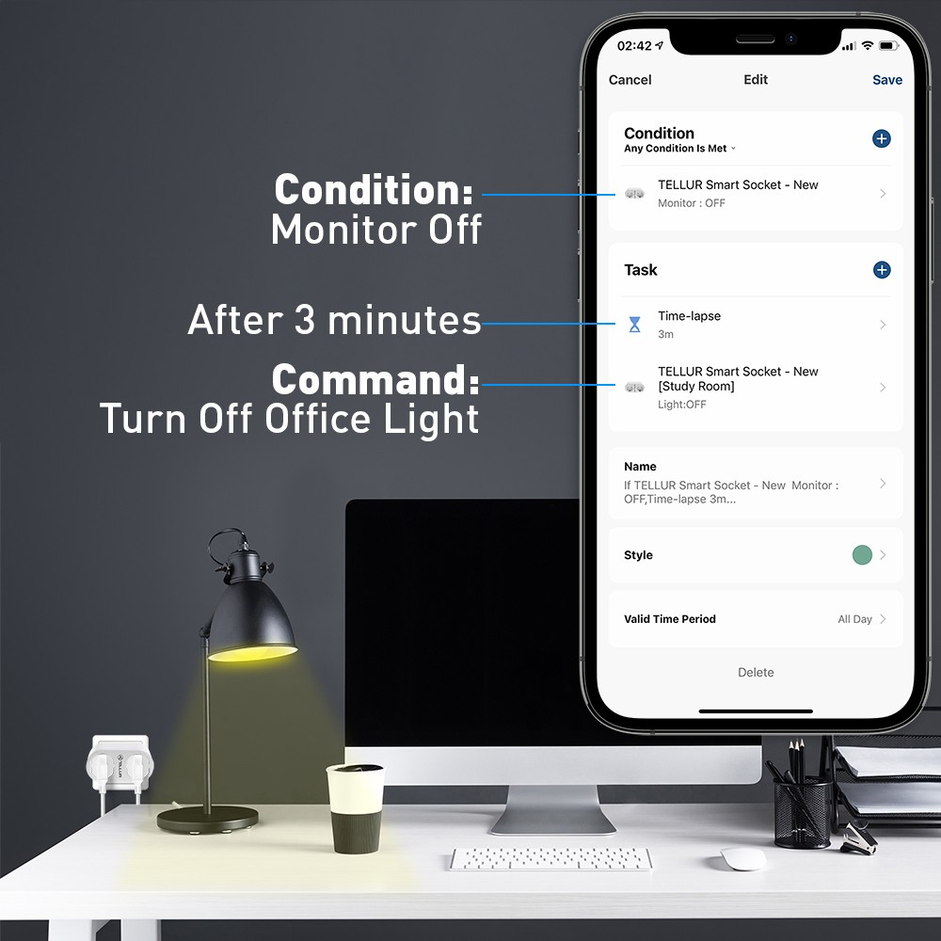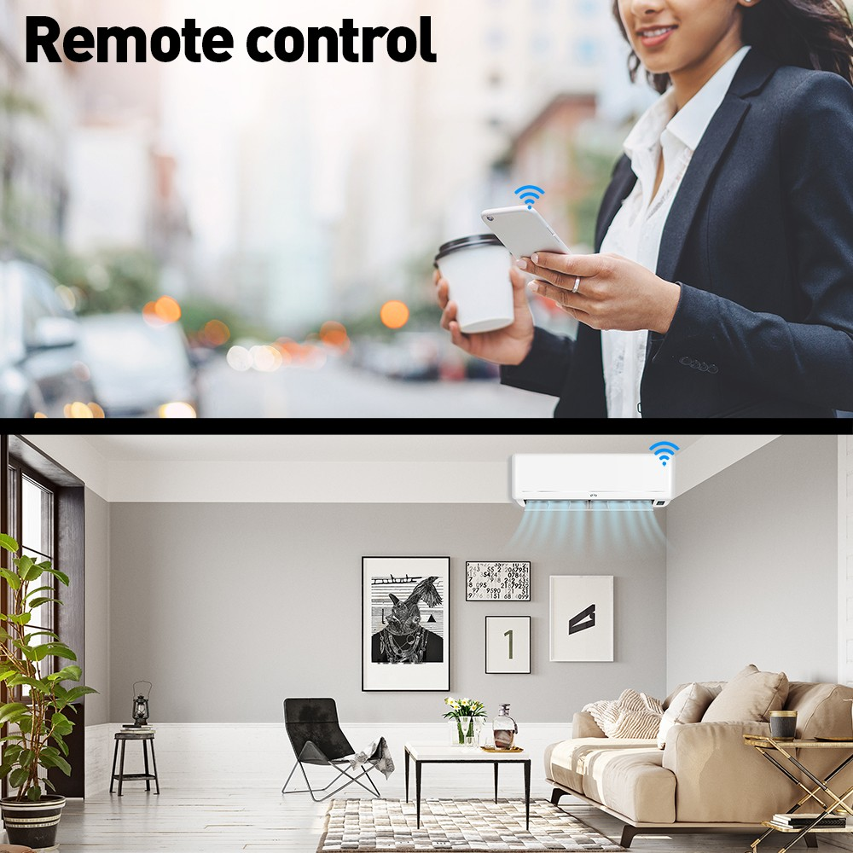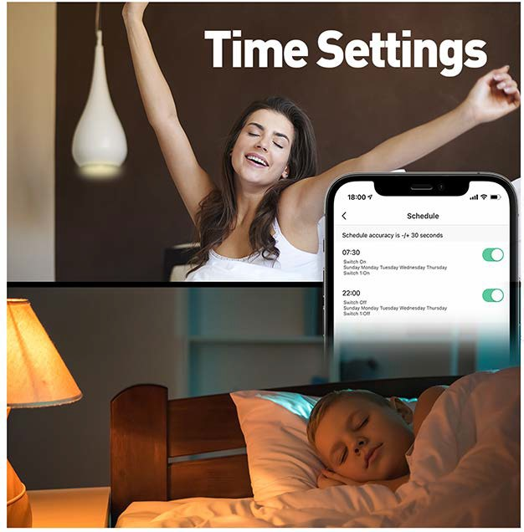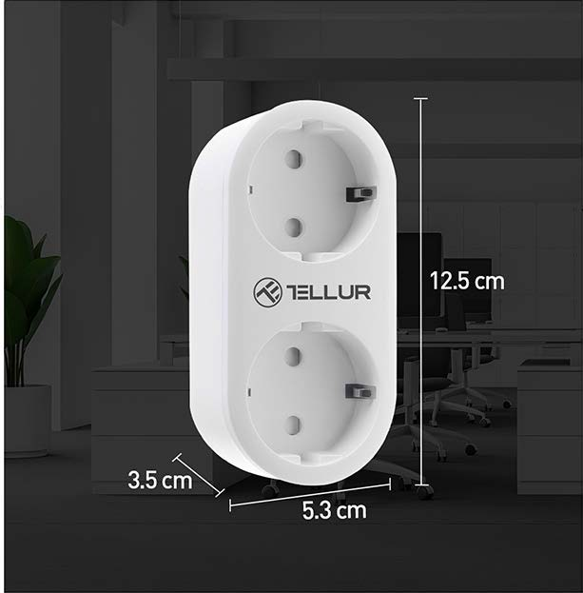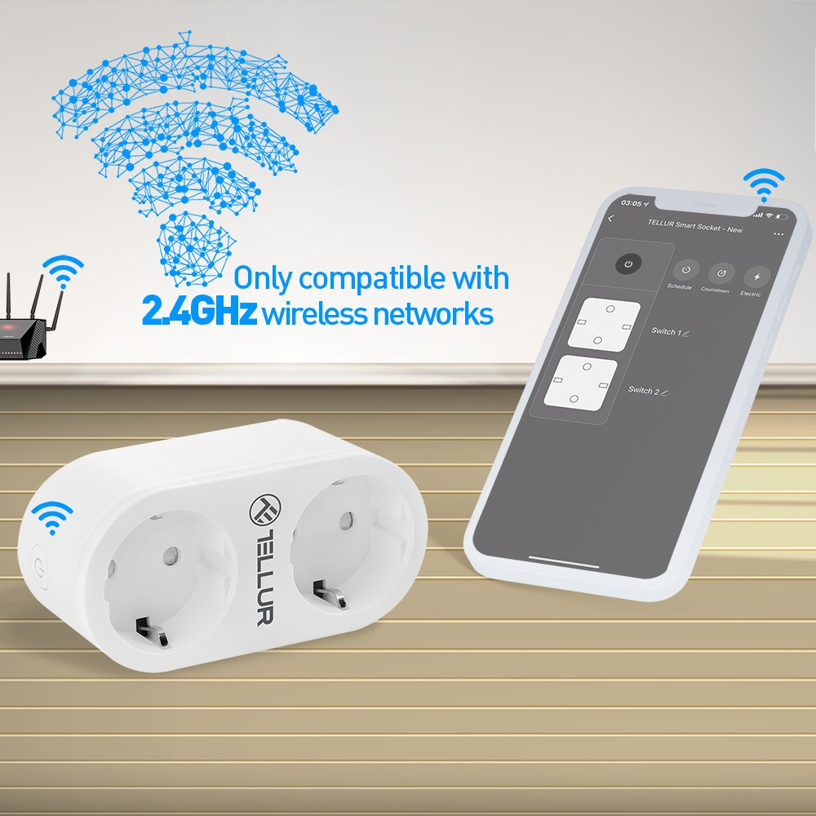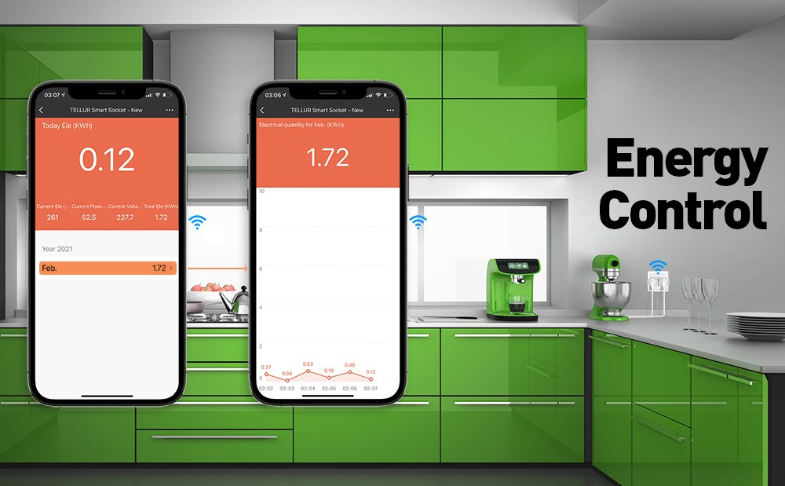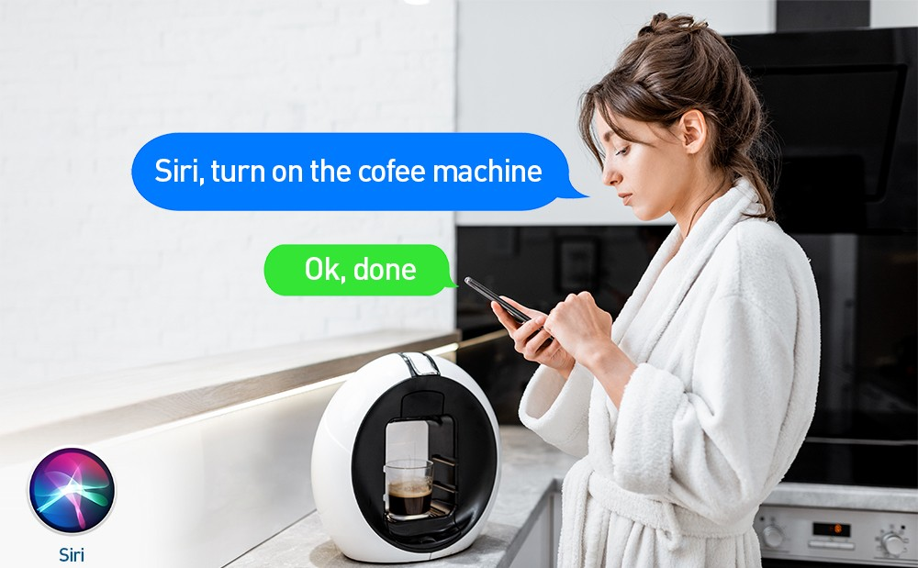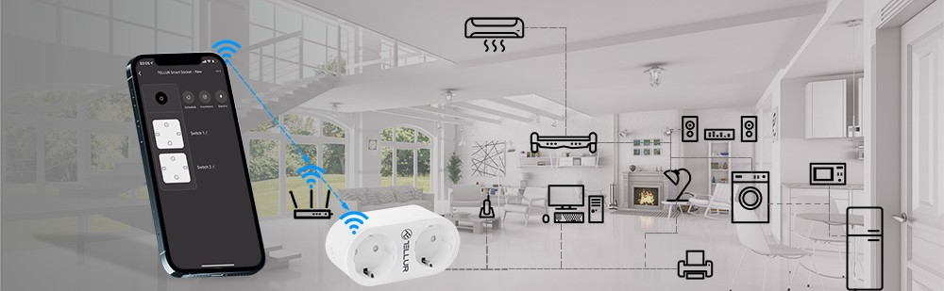

Set schedules as needed, save energy when electronic devices are not needed or do you want to have a comfort.

# Easy to install and use

Using Tellur Smart App, Smart Life or Tuya (IOS and Android). Independent use via the Internet, only with a smartphone.

No hub required. Supports up to 150 registered devices.

**Works only with 2.4GHz wireless networks**

# Dimensions

12.5cm X 5.3cm X 3.5cm